AWS Web Application Firewall (WAF)

TASK: Block my laptop ip using WAF.
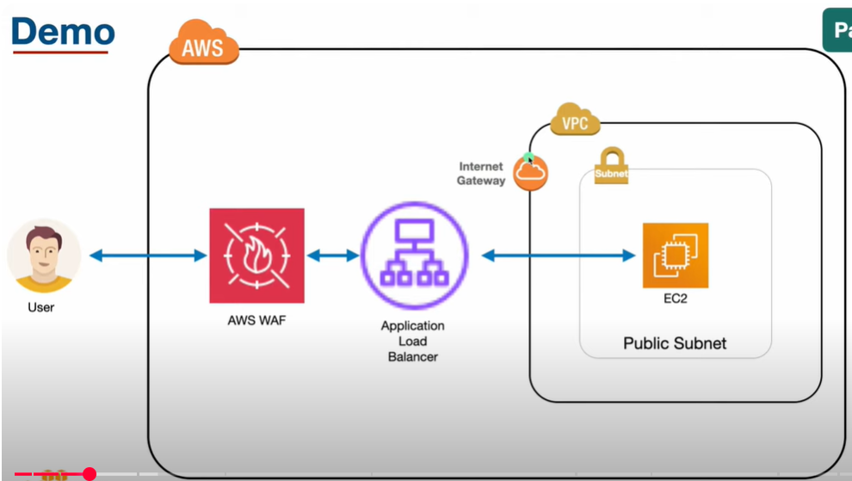

- Create a VPC , two different subnets in different zone and create a route table and connect igw, and create a EC2 and install apache, make sure security group inbound rule allows traffic for port 80.
- 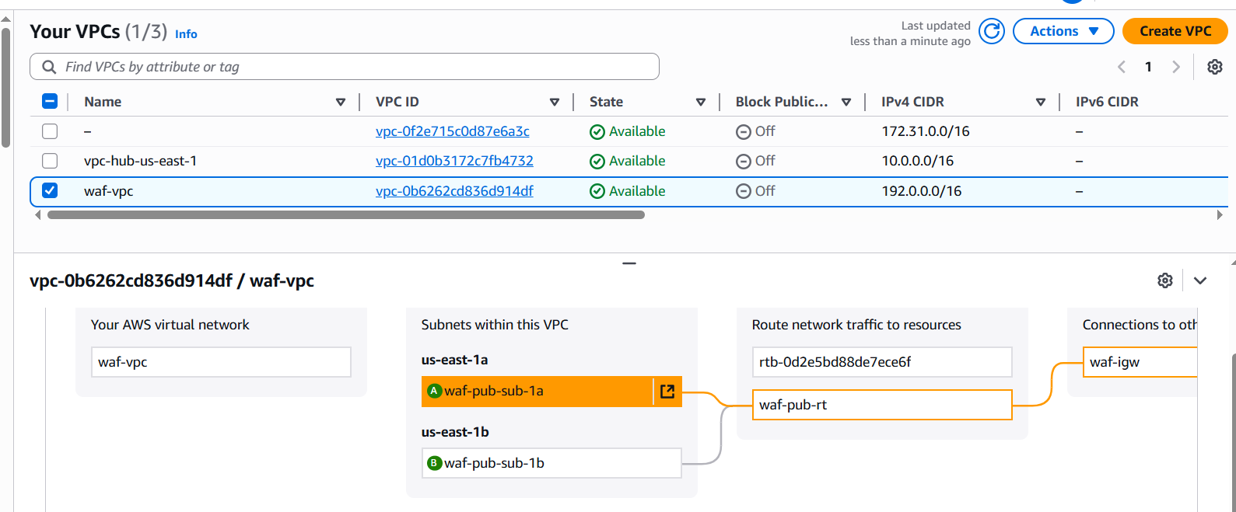
- 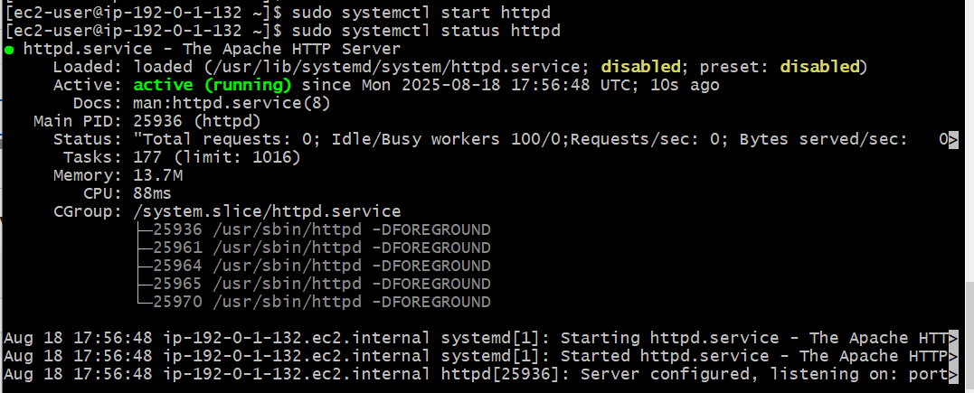
- Created a target group by adding instance and create a application load balancer with listener http port and attached the group.
- 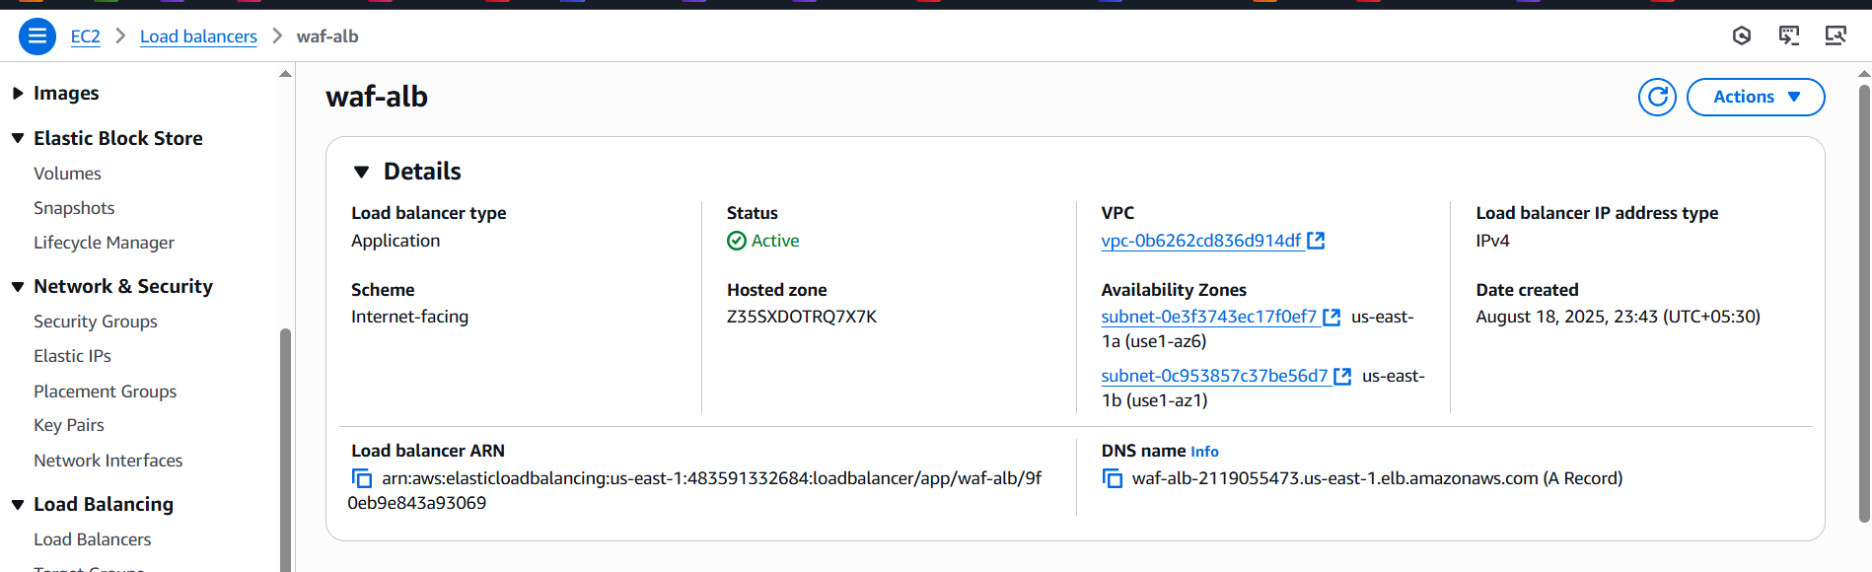
- 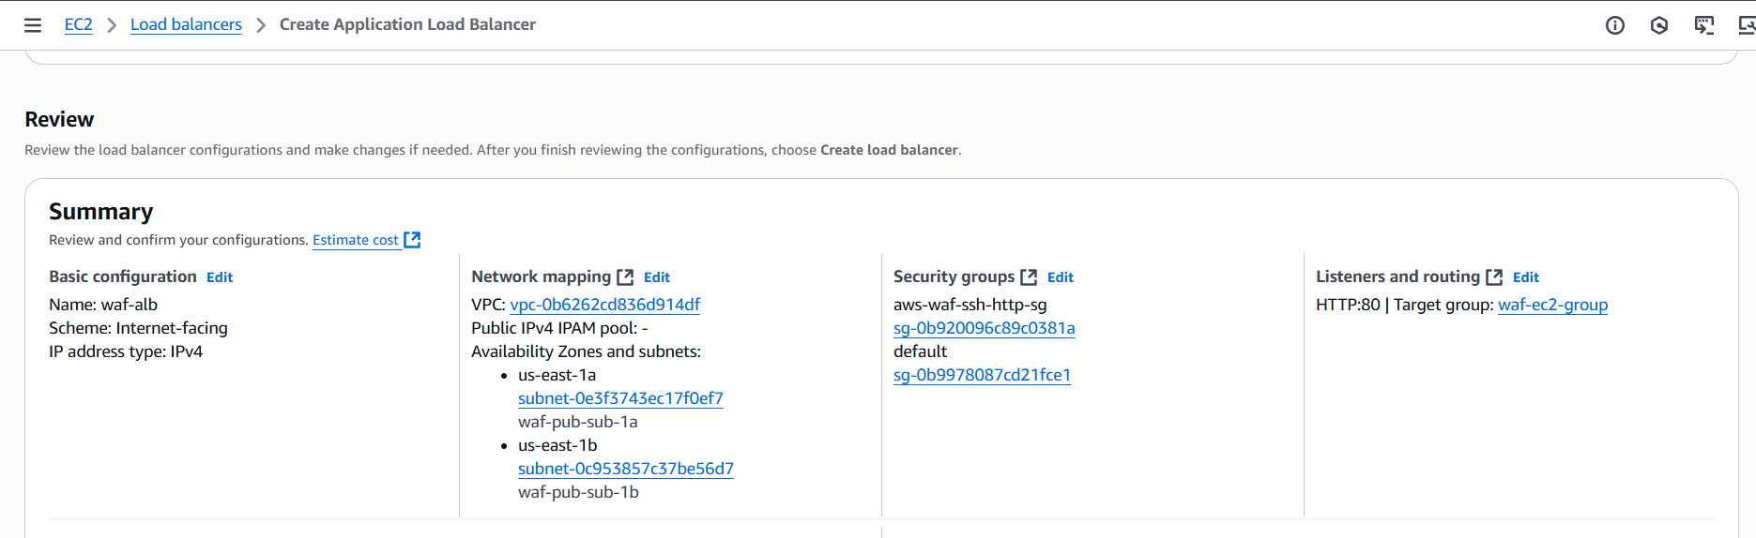
- Go to AWS WAF → IP SETS added my laptop for block.
- 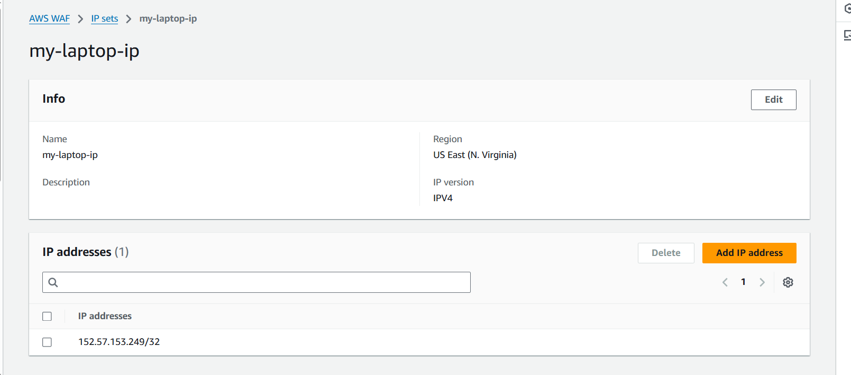
- Now created web application firewall and add the rule with above ip set.
- 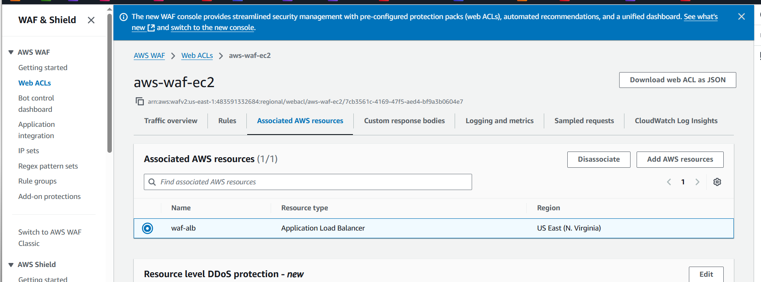
- 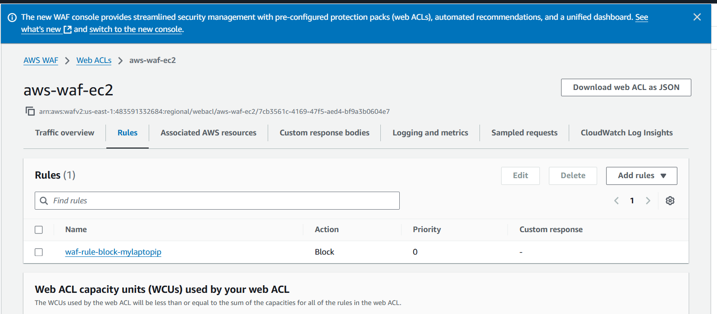
- Now copy the dns name and check in url
- waf-alb-2119055473.us-east-1.elb.amazonaws.com
- You will blocked.
- 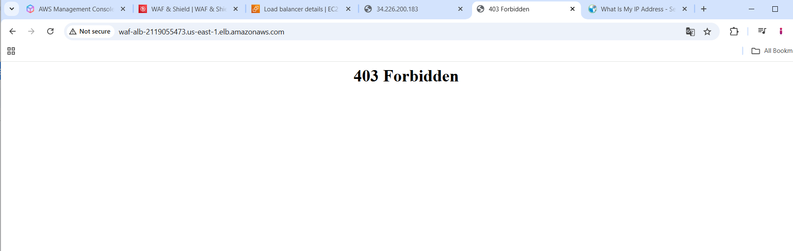
- Now in web acl edit the rule as captcha you will get this.
- 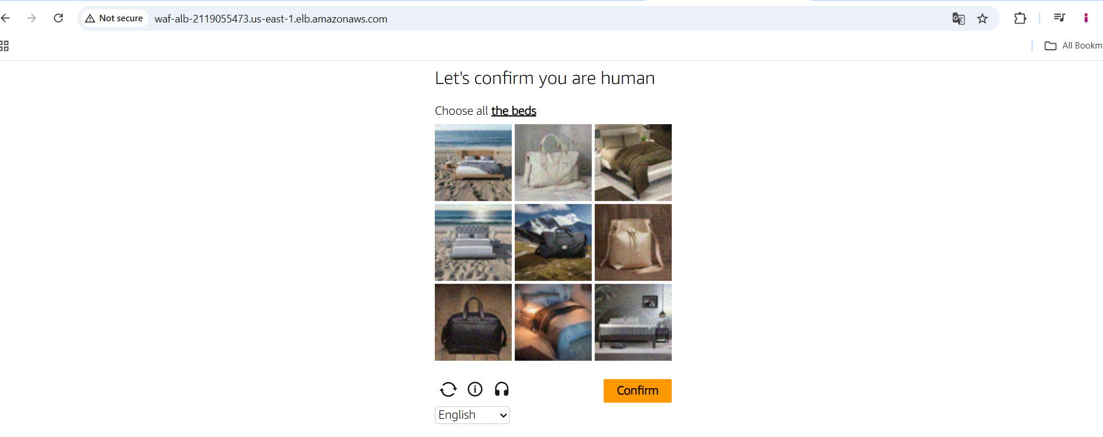
- Then its redirected to apache page
- 